**Cartooning of real image in python**

**KUMAR AAKARSHAN (18BCS6640), RITIK DHAND (18BCS6661), VANSHIKA (19BCS8002)**

[**18bcs6640@cuchd.in**](mailto:18bcs6640@cuchd.in)

[**18bcs6661@cuchd.in**](mailto:18bcs6661@cuchd.in)

[**19bcs8002@cuchd.in**](mailto:19bcs8002@cuchd.in)

Department of computer science

University institute of engineering

Chandigarh university

India

**Abstract -** Aim of the project is to put forward a solution for transforming snapshots of real-world into animated photos (Cartoon Images). The earlier method of transformation requires complicated computer graphics and skills. The idea of the paper is based on designated snapshots which are converted to an art form such as painting. Amongst all the techniques usable, the application of a OPEN CV called NUMPY will be used for the styling real-world images that use loss functions namely, content loss and adversarial loss for getting a sharp and clear image.

***Keywords*:** Entertainment, Image Processing, Animation, OPENCV., Cartooning of real image.

1. **INTRODUCTION**

Cartooning a digital image sounds a very interesting, fun and easy to work on. So as to achieve an animation picture from a digital image, we only need some bilateral filter and edge detection mechanism. These bilateral filters will assist us with reducing the color or shading palette of the image, which is an important step for the animation look, and edge detection are used to get a perfect bold silhouette.

In the past few years, image cartomizer-software has been used for converting the normal image into a cartoon image. In this process, edge detection and bilateral filter are required. The bilateral filter is used to reduce the color palette of an image. Afterward, we can apply edge detection to this image for generating a dark shaped image. Therefore, finally, some tricks can apply for this image to get a cartoon image.

1. **GOAL**

Image cartomizer-software has been used for converting the normal image into a cartoon image. In this process, edge detection and bilateral filter are required. The bilateral filter is used to reduce the color palette of an image. Afterward, we can apply edge detection to this image for generating a dark shaped image.

1. **METHODOLOGY**
2. The initial step of cartooning image is to apply the bilateral filter to decrease the shading or color palette of the image, which implies first we need to downscale the image and afterward apply the bilateral filter to get an animation flavor and again we upscale the image.
3. The next step is to get a blurred image of the real image. And we just need the blurring of the limits without colors to interfere in this process. So, for this, we first convert the genuine picture to grayscale.
4. The following stage is to apply the median blur so as to diminish image noise in the grayscale image.
5. Next, we make an edge mask from the grayscale image utilizing an adaptive thresholding technique.
6. In the last step, we have to recognize the edges in the image and afterward add this to the recently changed pictures to get cartoonish or sketch pen impact to the picture. After this step, we finally combine the final images obtained from the previous steps.
7. Here we get our cartoonist image.
8. DESIGN

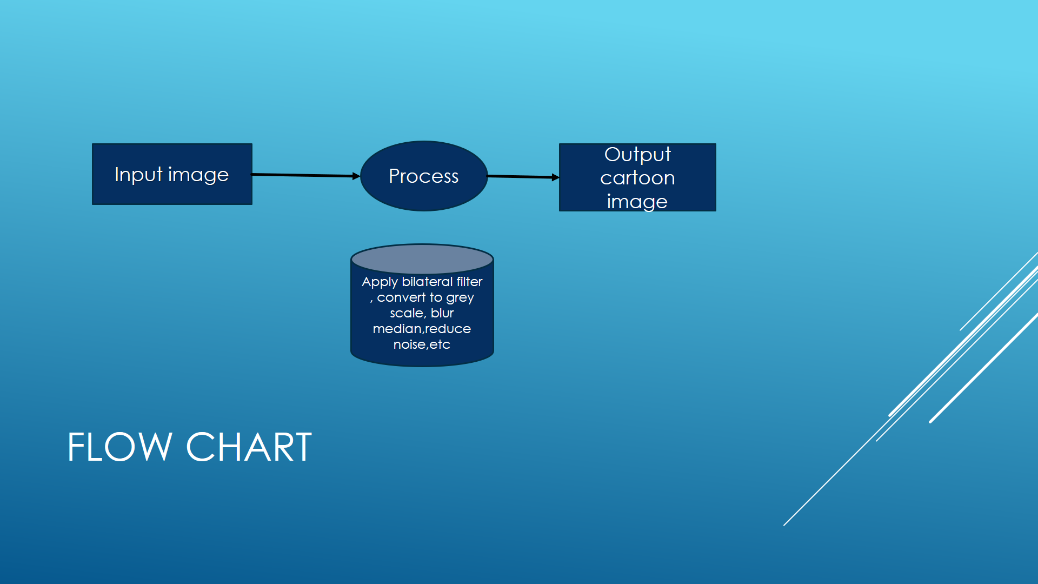

1. IMPLEMENTATION

* The initial step of cartooning image is to apply the bilateral filter to decrease the shading or color palette of the image, which implies first we need to downscale the image and afterward apply the bilateral filter to get an animation flavor and again we upscale the image.
* The next step is to get a blurred image of the real image. And we just need the blurring of the limits without colors to interfere in this process. So, for this, we first convert the genuine picture to grayscale.
* The following stage is to apply the median blur so as to diminish image noise in the grayscale image.
* Next, we make an edge mask from the grayscale image utilizing an adaptive thresholding technique.
* In the last step, we have to recognize the edges in the image and afterward add this to the recently changed pictures to get cartoonish or sketch pen impact to the picture. After this step, we finally combine the final images obtained from the previous steps.
* Here we get our cartoonist image.

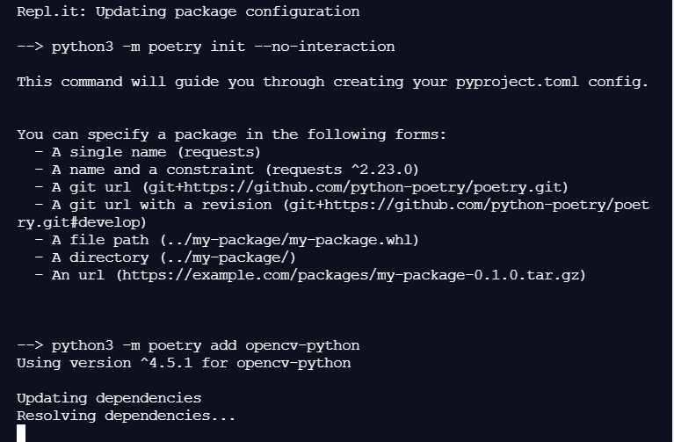

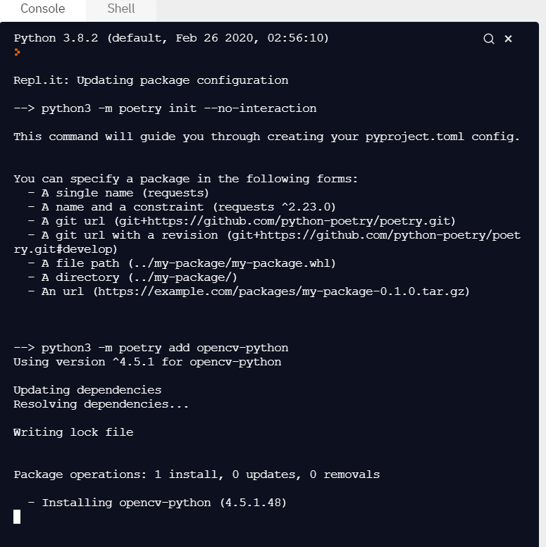

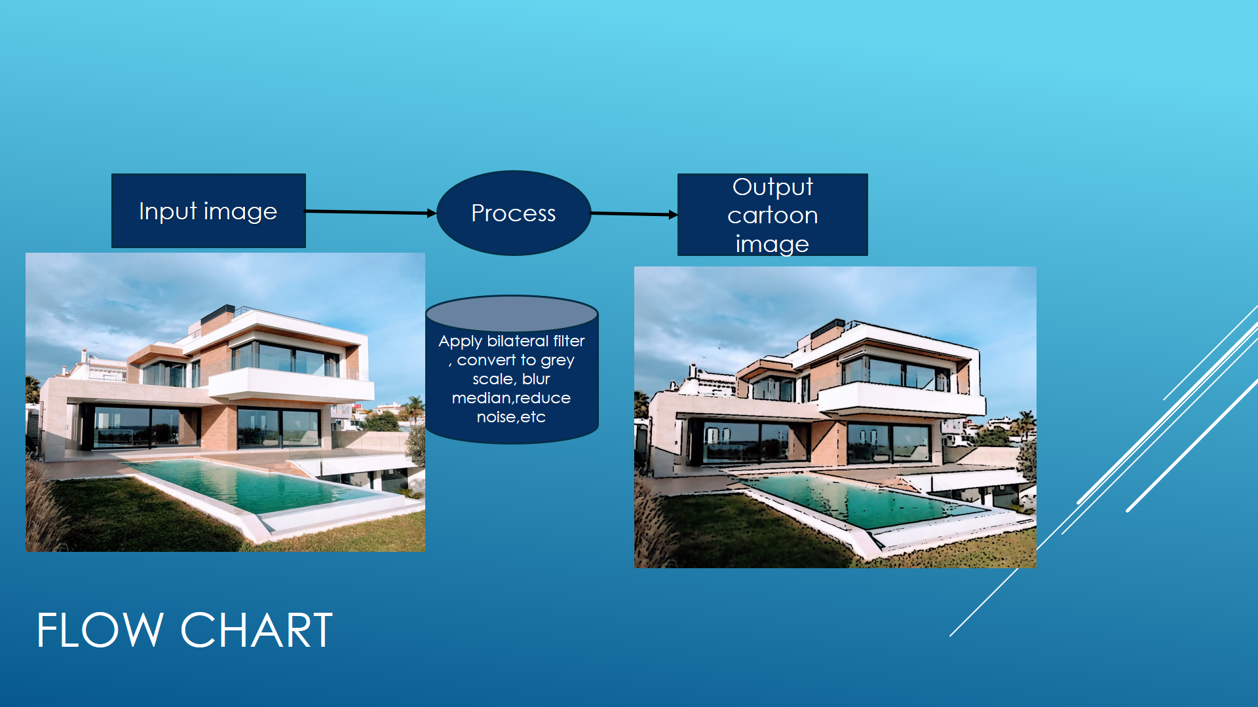

1. CONCLUSION

In this paper with the help of OPENCV,is used to transform images (snapshots) to the finest cartooned image(animated image ). With the help of the loss function and its two types named as Adversarial loss and Content Loss, we got a flexible as well as a clear edge defined images. Also with the help of CV which is known as Computer vision, we have TRANSFORMED IMAGE into cartoonistic image.

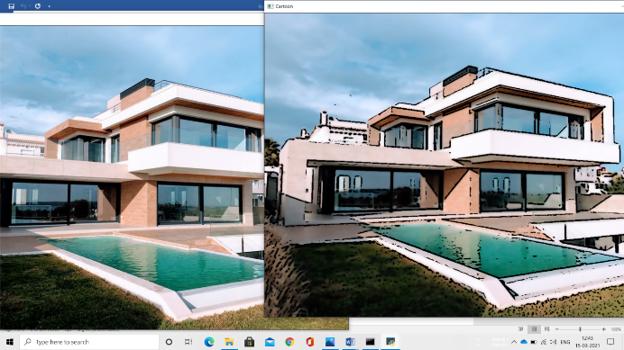

1. REFERENCES

[**https://www.skyfilabs.com/project-ideas/cartooning-an-image-using-open-cv**](https://www.skyfilabs.com/project-ideas/cartooning-an-image-using-open-cv)

[**https://www.elprocus.com/image-processing-projects-for-engineering-students/**](https://www.elprocus.com/image-processing-projects-for-engineering-students/)

[**https://www.geeksforgeeks.org/cartooning-an-image-using-opencv-python/**](https://www.geeksforgeeks.org/cartooning-an-image-using-opencv-python/)

[**https://github.com/**](https://github.com/)